**Dynamic Table**

1. **Task Description:**

The task involves creating a dynamic table in React. The table will automatically be generated based on the values from an array. Each row in the table will correspond to an item in the array, and each column will be created based on the properties of the objects in the array. The table will also support the addition and deletion of rows dynamically via an input form.

**The core features of this task include:**

* Dynamic table generation based on an array of data.
* Form for adding new entries to the table.
* Ability to delete individual rows from the table.

1. **Task Output Screenshot**

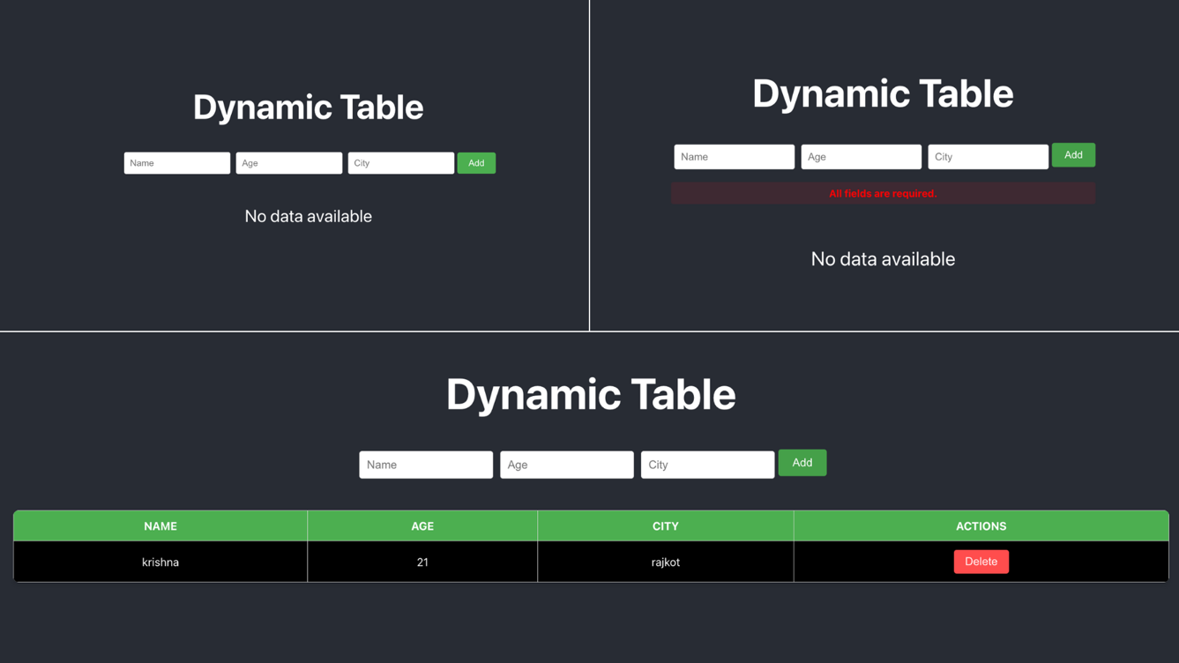

1. **Widget/Algorithm Used In Task**

**Widgets/Components Used:**

* **React useState Hook:**

This hook is used for managing the state of the data (data array) and handling form data (formData). It allows the table to dynamically update when new data is added or existing data is deleted.

* **Input Fields (HTML <input>):**

These are used to collect user input for fields like "Name," "Age," and "City." The inputs use state to handle form values and validations.

* **Button (HTML <button>):**

The button in the form is used to trigger the addition of data to the table. The "Delete" button in each row allows the removal of that row from the table.

* **Table (HTML <table>):**

The table is dynamically created using data passed from the state. The headers of the table are generated based on the keys of the first object in the data array.

* **Conditional Rendering ({error && <p>}):**

This is used to display error messages if the user tries to submit the form without filling all required fields or providing valid values (like a positive age).

* **Array Methods (map, filter):**
  + map method is used to iterate over the array and generate table rows and headers dynamically.
  + filter method is used to remove a specific item from the array when the delete button is clicked.